 | 26 Editors - Properties Editor
Table of content
Properties Editor 1
Hotkey functionality 1
Slider snapping 2
Header and Tabs 2
Search 2
Options 2
Sync with Outliner 2
On 2
Off 2
Auto 2
Context pin 2
Editortype Menu 3
Navigation Tabs 3
Tabs position 3
Globals section 3
Object Data Section 3
Properties Editor - Context menu 4
Area 4
Horizontal Split 4
Vertical Split 4
Duplicate Area into New Window 4
Toggle Maximize Area 4
Toggle Full screen Area 4

Properties Editor

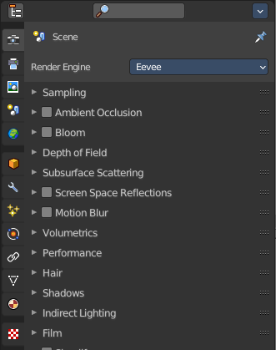
The Properties Editor is the core to manage the data in Bforartists. It is used to edit data and properties for the Active Scene and the Active Object. It contains Scene and Object related settings and properties. It contains all the tool settings for the current active tool. And it contains global settings and properties, like Render settings. Materials, Particle settings. etc.
The Properties editor is divided into several tabs. And the tabs are divided into several panels. The tabs buttons can be found asides.
Various content just appears when you are in the right context. Means when you have a specific object type selected, are in a specific mode, etc.

Hotkey functionality
You can scroll through the tabs by holding down ctrl and using the scroll wheel.

Slider snapping
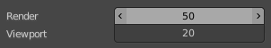
Snapping also works at sliders. Hover with the mouse over the slider, start to slide, and holding down Ctrl will snap the sliders in incremental steps.
When it's a default value between 0 and 1 then it usually snaps in 0.1 steps. When it's a default value over 1 then it usually snaps in steps of 10.

Header and Tabs

The header contains a button to switch to Outliner and back. And it contains a search and a context pin.

Search
Allows you to search for specific terms. All not matching content is greyed out. When the matching term is in one of the closed panels, then this panel will open up.

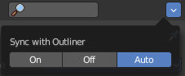
Options

Sync with Outliner
Adjust if properties editor is in sync with the outliner. It can make sense to turn off sync for performance reasons.

On
Always sync outliner with properties editor.

Off
Never sync outliner with properties editor.

Auto
Sync outliner with properties editor when they share an edge with each other.

Context pin
The header can also contain a pin icon in some areas. This pin icon allows you to collapse the tabs to just the tabs that are available for the currently selected kind of object type.

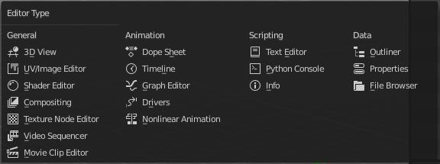
Editortype Menu
You can display a Editortype Menu in the header. This menu allows you to switch to another editor type. Note that this menu is hidden by default. You can reveal it in the right click menu of the header area.

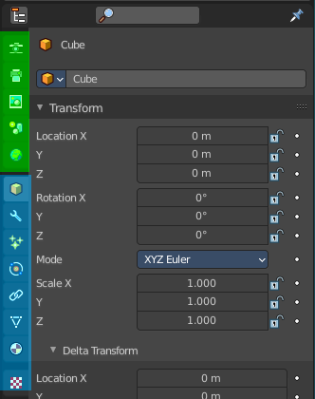
Navigation Tabs
The navigation tabs to navigate in the Properties Editor are vertically aligned besides the editor.
It is divided into two sections. Globals Section. Green. and Object Data section. Blue.

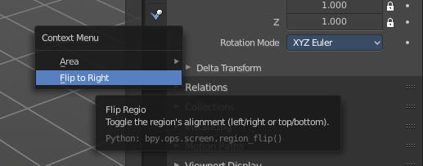
Tabs position
The tabs can be displayed at the left or at the right side. Either click right in the empty space of the tab area. This will bring up the Context menu where you can flip the whole tabs menu bar to the right or to the left. Or move with the mouse over the area and press F5.
The navigation tabs are divided into three groups. Tools section, Globals section and Object Data Section. We will cover the content of the different tabs in the corresponding section of the manual.


Globals section
The Globals section contains everything that is not related to the currently selected object. But global. Render settings, View-, Scene- and World settings.


Object Data Section
The Object Data section contains everything that is related to the currently selected object. From mesh data across material up to texture and particle system.
The content differs, dependent of the currently active object. For an Armature you will have other tabs than for a Mesh object, and other tabs for a Lattice object for example.
There are some general tabs though for all object types. Like Object, Constraints, Texture, or Physics tab.

Properties Editor - Context menu

When you click into an empty area of the Properties editor then you call the context menu.

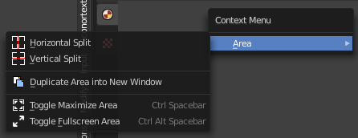
Area
This menu contains general view functionality. And exists in most other editor types too.

Horizontal Split
Splits the current view horizontally into two independent editor windows.

Vertical Split
Splits the current view vertically into two independent editor windows.


Duplicate Area into New Window
Duplicate Area into New Window makes the selected editor window floating. You can then drag it around at the monitor. It is not connected with the rest of the UI anymore.
A separated window cannot be merged into the main window again. You have to close it when not longer needed.

Toggle Maximize Area
Displays the editor maximized with menus.
To return from the maximized view press hotkey ctrl + spacebar. Or reuse the menu item in the area menu.

Toggle Full screen Area
Displays the editor maximized without menus.
To return from the full screen view press hotkey ctrl + alt + spacebar.

